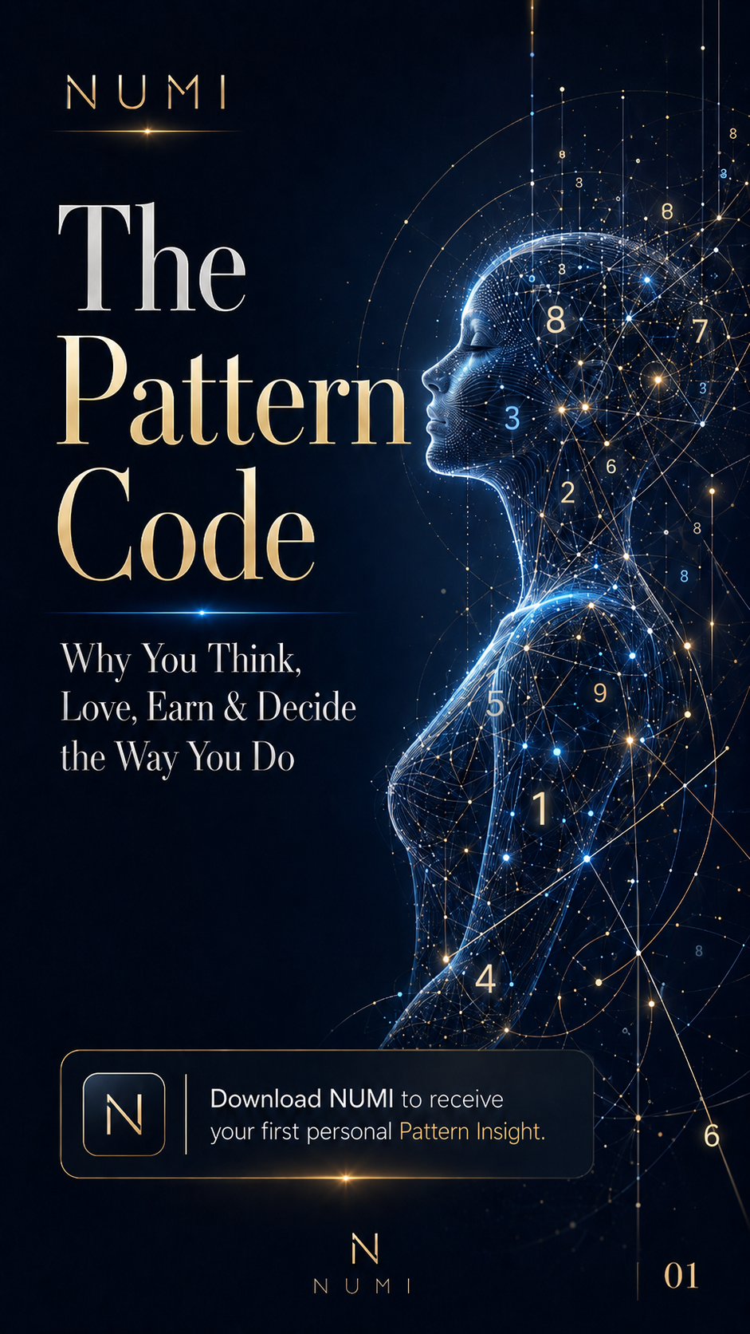

The Pattern Code

What Your Number Reveals About How You Think, Love, Earn & Succeed
Small line: Inspired by Dato’ Patrick Tan’s number intelligence methodology. Powered by NUMI.
CTA: Scan the QR code inside to unlock your full Pattern Insight.

Page 2 — Hook

Your Number Is More Than a Number
Your number can act like a mirror.
It may reveal how you think, love, earn, decide, lead, react, and repeat certain patterns.
This guide gives you a quick preview.
NUMI gives you the full AI-powered interpretation.

Page 3 — How to Calculate Your Core Number

Find Your Core Number
Add all digits in your date of birth until you get one final number between 1 and 9.
Example: 24 August 1992 2 + 4 + 0 + 8 + 1 + 9 + 9 + 2 = 35 3 + 5 = 8
Core Number: 8
Note: This is a simplified preview. NUMI provides a deeper reading inside the app.

Page 4 — Number 1: The Initiator

1 — The Initiator

Your Light Side
You are independent, bold, direct, and naturally driven to start things. You are often at your best when you are trusted to lead, decide, and move first.
You may carry strong personal ambition and a desire to prove yourself through action.

Your Shadow Side
You may become impatient, controlling, overly self-reliant, or frustrated when others cannot keep up. You may also struggle to ask for help because you feel you should handle everything alone.

NUMI Prompt
Ask NUMI: “What leadership pattern should I understand about myself?”

Page 5 — Number 2: The Connector

2 — The Connector

Your Light Side
You are sensitive, intuitive, cooperative, and emotionally aware. You often understand people’s feelings before they say anything.
You are strongest when you create harmony, trust, and meaningful connection.

Your Shadow Side
You may overthink other people’s reactions, avoid confrontation, or put others’ needs before your own. You may stay silent to keep peace, even when something hurts you.

NUMI Prompt
Ask NUMI: “What emotional pattern should I stop ignoring?”

Page 6 — Number 3: The Communicator

3 — The Communicator

Your Light Side
You are expressive, creative, social, and naturally gifted at sharing ideas. You may inspire others through your words, humour, charm, or imagination.
You are strongest when you allow yourself to be seen and heard.

Your Shadow Side
You may scatter your energy, avoid discipline, hide pain behind humour, or start many things without completing them. Your creativity needs structure to become success.

NUMI Prompt
Ask NUMI: “How can I turn my ideas into consistent results?”

Page 7 — Number 4: The Builder

4 — The Builder

Your Light Side
You are practical, reliable, disciplined, and grounded. You are built to create structure, stability, and long-term results.
People may depend on you because you are consistent and responsible.

Your Shadow Side
You may become rigid, overly serious, resistant to change, or trapped in duty. You may work hard but forget to ask whether the structure you are building still supports your happiness.

NUMI Prompt
Ask NUMI: “Where am I working hard but not working wisely?”

Page 8 — Number 5: The Explorer

5 — The Explorer

Your Light Side
You are adaptable, curious, persuasive, and freedom-driven. You learn through experience, movement, people, and change.
You are strongest when life gives you room to explore, communicate, and evolve.

Your Shadow Side
You may resist commitment, become easily bored, chase too many options, or confuse freedom with avoidance. Without direction, your flexibility can become distraction.

NUMI Prompt
Ask NUMI: “What freedom pattern is helping or hurting me?”

Page 9 — Number 6: The Nurturer

6 — The Nurturer

Your Light Side
You are caring, responsible, protective, and naturally drawn to support others. You may have strong family, relationship, beauty, service, or healing energy.
You are strongest when your care is balanced with self-respect.

Your Shadow Side
You may overgive, carry other people’s problems, become controlling in the name of love, or feel guilty when choosing yourself. Your lesson is often boundaries.

NUMI Prompt
Ask NUMI: “Where am I giving too much of myself?”

Page 10 — Number 7: The Analyst

7 — The Analyst

Your Light Side
You are reflective, intelligent, observant, and drawn to truth. You may need depth, privacy, research, and meaning before you fully trust something.
You are strongest when you honour your inner wisdom.

Your Shadow Side
You may isolate, overanalyse, distrust others, or retreat into your mind when emotions feel uncomfortable. You may know a lot but still struggle to open up.

NUMI Prompt
Ask NUMI: “What pattern keeps me emotionally guarded?”

Page 11 — Number 8: The Strategist

8 — The Strategist

Your Light Side
You are ambitious, powerful, strategic, and results-oriented. You may be naturally drawn to leadership, business, influence, money, and achievement.
You are strongest when your power is guided by purpose and responsibility.

Your Shadow Side
You may become overly controlling, status-driven, impatient, or harsh on yourself when results are slow. You may also tie your worth too closely to success.

NUMI Prompt
Ask NUMI: “What money or power pattern should I understand?”

Page 12 — Number 9: The Visionary + Final CTA

9 — The Visionary

Your Light Side
You are compassionate, wise, big-picture, and deeply connected to meaning. You may feel called to help, teach, inspire, transform, or contribute to something larger than yourself.
You are strongest when your purpose has direction.

Your Shadow Side
You may carry emotional weight, struggle to let go, feel responsible for everyone, or become disappointed when the world does not match your ideals.

NUMI Prompt
Ask NUMI: “What purpose pattern is guiding my next chapter?”

Unlock Your Full Pattern Insight
This guide only shows one layer of your number.
Inside NUMI, you can discover your deeper:
- Thinking pattern
- Love pattern
- Wealth pattern
- Success pattern
- Decision style
- Daily AI-powered guidance

Scan the QR code to download NUMI
CTA Button: Get My Free Pattern Insight

